**Assignment Number 9**

Discrete Distributions Using SPSS

Register Number: 1740256

**Date:** 12/2/2018

---------------------------------------------------------------------------

**Question 1**

**Aim** – The U.S. Department of Transportation reported that in 2009, Southwest led all domestic airlines in on-time arrivals for domestic flights, with a rate of 0.825. Obtain the pmf and cdf of the binomial distribution. What is the probability that in the next six flights?

a. four flights will be on time?

b. all six flights will be on time?

c. at least four flights will be on time?

Find the required figures.

**Procedure –**

1. In SPSS, create a variable (x) to serve the purpose of a random variable with values from 0 to 6 inclusive.
2. In the “Transform” dropdown list, click on “Compute Variable”.
3. Once the dialog box opens, in the “Target Variable” box, type the target variable (PMF/CDF).
4. Depending on the Target Variable, choose an appropriate “Function Group”. (PDF & Noncentral PDF/CDF & Noncentral CDF)
5. Then choose the appropriate Function in the “Functions and Special Variables” box. (Pdf.Binom(x, n, p)/Cdf.Binom(x, n, p))
6. Then, finally, click on “Ok”.

**Calculations -**

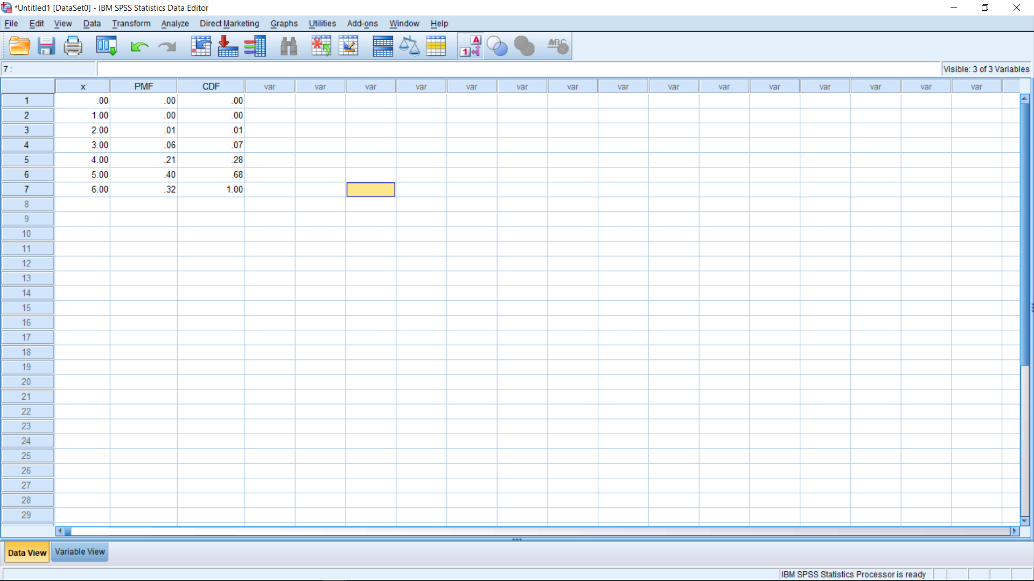

**Conclusions -**

With the help of SPSS, the PMF and CDF of a binomial distribution can be found at ease.

The probability that four flights will be on time is P(X=4) = 0.21. The probability that all six flights will be on time is F(6) = 1.00. The probability that at least four flights will be on time is 1 – (P(X=0) + P(X=1) + P(X=2) + P(X=3)) = 1-0.00-0.00-0.01-0.06 = 0.93.

---------------------------------------------------------------------

**Question 2**

**Aim** – The U.S. Department of Transportation maintains statistics for consumer complaints per 100,000 airline passengers. In the first nine months of 2009, consumer complaints were 0.99 per 100,000 passengers. What is the probability that in the next 100,000 passengers, there will be:  
a. no complaints? – 0.37  
b. at least one complaint? – 0.63   
c. at least two complaints? – 0.26  
Find the required figures.

**Procedure –**

1. In SPSS, create a variable (x) to serve the purpose of a random variable with values from 0 to 2 inclusive.
2. In the “Transform” dropdown list, click on “Compute Variable”.
3. Once the dialog box opens, in the “Target Variable” box, type the target variable (PMF/CDF).
4. Depending on the Target Variable, choose an appropriate “Function Group”. (PDF & Noncentral PDF/CDF & Noncentral CDF)
5. Then choose the appropriate Function in the “Functions and Special Variables” box. (Pdf.Poisson(x, mean)/Cdf.Poisson(x,mean))
6. Then, finally, click on “Ok”.

**Calculations -**

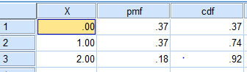

**Conclusions -**

1. no complaints? – **0.37**
2. at least one complaint? – **0.63** ;1 - P(X=0)
3. at least two complaints? – **0.26;**

**P(X>=2) = 1-P(X<2) = 1 – 0.37 – 0.37 = 0.26**

---------------------------------------------------------------------

**Question 3**

**Aim** – The average number of annual trips per family to amusement parks in the United States is Poisson distributed, with a mean of 0.6 trips per year. What is the probability of randomly selecting an American family and finding the following?  
a. The family did not make a trip to an amusement park last year.  
b. The family took exactly one trip to an amusement park last year.  
c. The family took two or more trips to amusement parks last year.  
Find the required figures.

**Procedure –**

1. In SPSS, create a variable (x) to serve the purpose of a random variable with values from 0 to 2 inclusive.
2. In the “Transform” dropdown list, click on “Compute Variable”.
3. Once the dialog box opens, in the “Target Variable” box, type the target variable (PMF/CDF).
4. Depending on the Target Variable, choose an appropriate “Function Group”. (PDF & Noncentral PDF/CDF & Noncentral CDF)
5. Then choose the appropriate Function in the “Functions and Special Variables” box. (Pdf.Poisson(x, mean)/Cdf.Poisson(x,mean))
6. Then, finally, click on “Ok”.

**Calculations -**

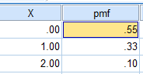

**Conclusions -**

a. The family did not make a trip to an amusement park last year. – **0.55**  
b. The family took exactly one trip to an amusement park last year. – **0.33**  
c. The family took two or more trips to amusement parks last year; P(X>=2) = 1 – P(X<2) = 1 – P(X=0) – P(X=1) = 1 – 0.55 – 0.33 = **0.12**

---------------------------------------------------------------------

**Question 4**

**Aim** – Suppose that in the inspection of metal produced in continuous rolls the number of imperfections spotted by an inspector during a 10-minute period is a random variable having the Poisson distribution with λ= 1.7 = np = mean. Find the probabilities that during a 10-minutes period an inspector will find:  
a. no imperfection  
b. two imperfections  
c. one imperfection  
d. at least three imperfections  
Find the required figures.

**Procedure –**

1. In SPSS, create a variable (x) to serve the purpose of a random variable with values from 0 to 4 inclusive.
2. In the “Transform” dropdown list, click on “Compute Variable”.
3. Once the dialog box opens, in the “Target Variable” box, type the target variable (PMF/CDF).
4. Depending on the Target Variable, choose an appropriate “Function Group”. (PDF & Noncentral PDF/CDF & Noncentral CDF)
5. Then choose the appropriate Function in the “Functions and Special Variables” box. (Pdf.Poisson(x, mean)/Cdf.Poisson(x,mean))
6. Then, finally, click on “Ok”.

**Calculations -**

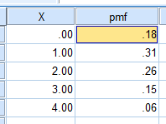

**Conclusions -**

a. no imperfection = **0.18**  
b. two imperfections = **0.26**  
c. one imperfection = **0.31**  
d. at least three imperfections = P(X>=3) = 1 – P(X<3) = 1 – P(X=0) – P(X=1) – P(X=2) = 1 – 0.18 – 0.31 – 0.26 = **0.25**

---------------------------------------------------------------------